Roux-en-Y Gastric Bypass – Patient Information Leaflet

1. What is a Gastric Bypass?
A Roux-en-Y gastric bypass (RYGB) is a well-established and highly effective form of bariatric (weight-loss) surgery.
It reduces the size of your stomach and reroutes part of your small intestine, leading to powerful effects on appetite, digestion, and metabolism.
This operation has been performed safely for decades and remains the benchmark for long-term weight control and diabetes improvement.
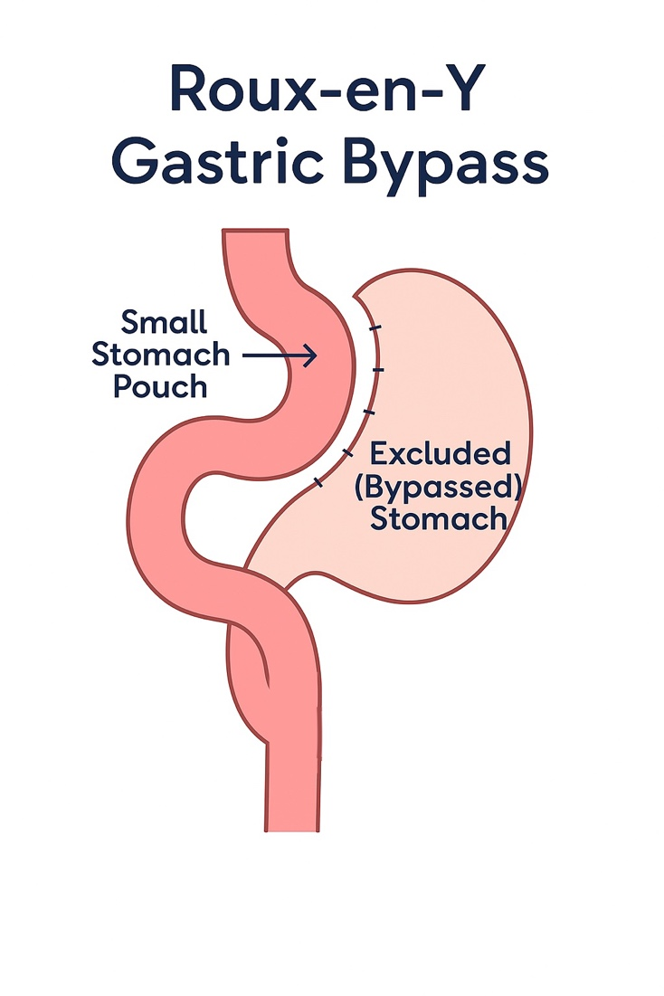
2. How Does it Work?
- Restriction: A small stomach pouch (about the size of an egg) limits how much food you can eat.
- Malabsorption: A section of intestine is bypassed, reducing calorie and nutrient absorption.
- Hormonal effect: The procedure alters gut hormones (such as GLP-1 and PYY), which reduce hunger and improve insulin control.

3. Benefits
- Sustained weight loss (typically 65–80% of excess body weight).
- High rates of type 2 diabetes remission.
- Improvement in blood pressure, cholesterol, and sleep apnoea.
- Often reduces or eliminates acid reflux (for patients with GORD).
- Long-term stability of results with structured aftercare.

4. The Operation
- Performed laparoscopically (keyhole) or robotically under general anaesthetic.
- A small pouch is created from the top of the stomach.
- The small intestine is divided and connected to this pouch, bypassing the rest of the stomach.
- The operation typically takes 90–120 minutes.
- Most patients stay in hospital for one night.

5. Risks and Possible Complications
All operations carry some risk. The main risks of RYGB include:
- General surgical risks: bleeding, infection, blood clots, anaesthetic complications.
- Specific risks:
• Leak from staple lines or bowel joins.
• Narrowing (stricture) at the join.
• Internal hernia (bowel twisting).
• Nutritional deficiencies (iron, B12, folate, calcium, vitamin D).
• Dumping syndrome (lightheadedness after sugary foods).
- Long-term: weight regain if diet and lifestyle are not maintained.

6. Recovery After Surgery
- Hospital stay: one night.
- Mobilisation: same day.
- Back to work: typically 3-4 weeks.
- Exercise: walking early on; avoid heavy lifting for 4–6 weeks.
- Follow-up: structured review with your surgeon, nurse, and dietitian.

7. Diet After Surgery
You will receive a separate diet sheet, which is also available on the website.
Stage 1 – Liquids (Weeks 1–2):
Smooth soups, protein drinks, clear fluids.
Stage 2 – Pureed (Weeks 3–4):
Soft blended foods (pureed meat/fish, mashed potato, yoghurt).
Stage 3 – Soft foods (Weeks 5–6):
Soft, moist foods like scrambled eggs, minced meat, soft fruit.
Stage 4 – Normal healthy diet (After 6 weeks):
Gradual return to solids. Focus on protein first, then vegetables and complex carbs.
Golden rules:
Eat slowly, stop when full, avoid sugary foods and fizzy drinks, take lifelong vitamin supplements, and stay hydrated.

8. Lifestyle Changes
- Maintain healthy eating and activity habits for life.
- Regular exercise supports long-term success.
- Attend all follow-ups and support sessions.
- Avoid smoking and limit alcohol.

9. Long-Term Results
- Weight loss of 65–80% of excess body weight.
- Improved or resolved diabetes, hypertension, and cholesterol.
- Sustained improvements in health and quality of life.

