One-Anastomosis Gastric Bypass (OAGB / Mini Bypass) – Patient Information Leaflet

1. What is a Mini Gastric Bypass?
A Mini Gastric Bypass (OAGB), also known as One-Anastomosis Gastric Bypass, is a modern variation of the traditional gastric bypass.
It provides similar results to the Roux-en-Y but with a simpler, single connection between the stomach and intestine.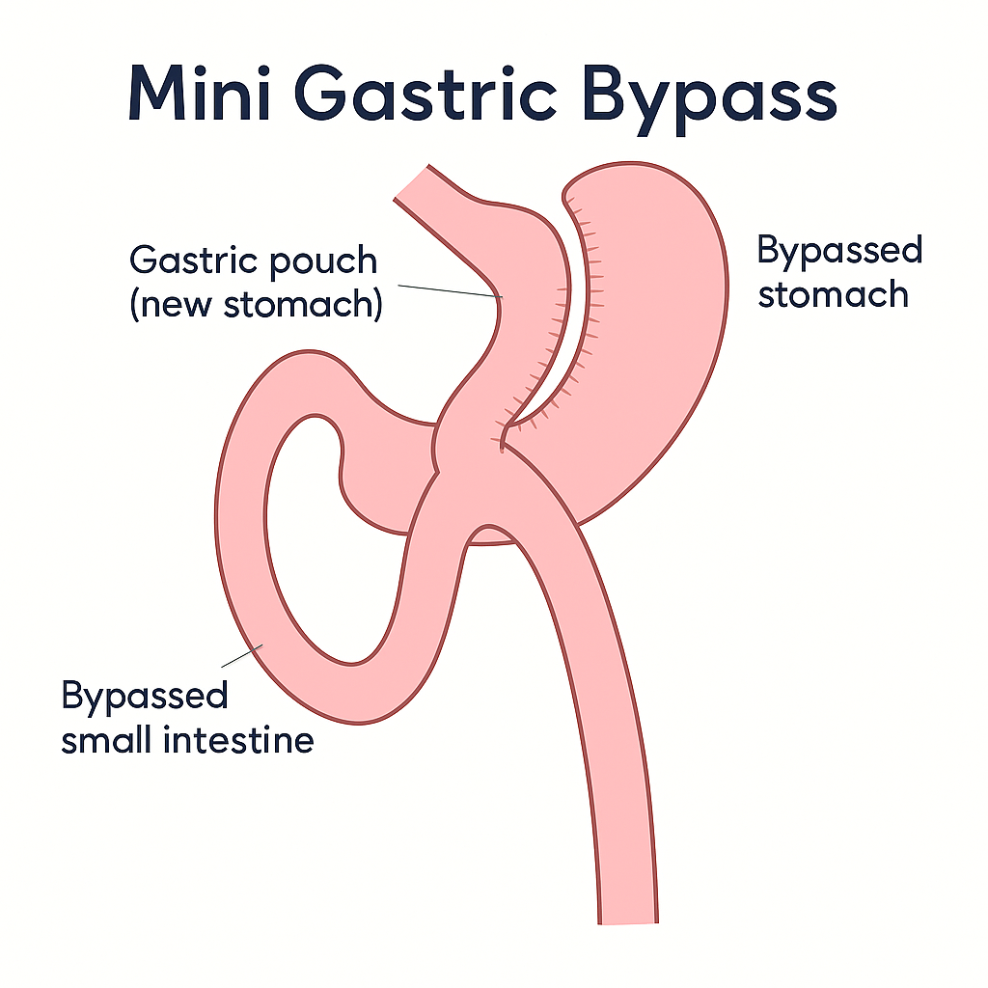

2. How Does it Work?
- Restriction: A long, narrow stomach pouch limits how much food you can eat.
- Malabsorption: Food bypasses part of the intestine, reducing calorie absorption.
- Hormonal effect: Changes in gut hormones reduce hunger and improve metabolism.

3. Benefits
- Weight loss comparable to the traditional gastric bypass.
- Shorter operation time and fewer connections.
- Excellent diabetes remission and metabolic results.
- Durable long-term success and patient satisfaction.

4. The Operation
- Performed laparoscopically or robotically under general anaesthetic.
- The stomach is divided into a narrow pouch.
- The small intestine is attached directly to this pouch through one connection.
- The operation typically takes 60–90 minutes.
- Most patients stay in hospital for one night.

5. Risks and Possible Complications
- General risks: bleeding, infection, clots, anaesthetic risks.
- Specific risks:
• Leak from the join (anastomosis).
• Bile reflux (in a small number of patients).
• Nutritional deficiencies (iron, B12, folate, vitamin D).
• Stricture at the join.
• Dumping syndrome (reaction to sugary foods).
- Long-term: risk of weight regain if diet and activity are not maintained.

6. Recovery After Surgery
- Hospital stay: one night.
- Walking: same day.
- Normal activities: 2–3 weeks.
- Exercise: gentle walking early; avoid heavy lifting for 4–6 weeks.
- Follow-up: regular appointments with your bariatric team.

7. Diet After Surgery
You will receive a separate diet sheet, which is also available on the website.
- Stage 1 – Liquids (Weeks 1–2)
- Stage 2 – Pureed (Weeks 3–4)
- Stage 3 – Soft (Weeks 5–6)
- Stage 4 – Normal healthy diet (After 6 weeks)
Focus on protein first, eat slowly, avoid sugary and fatty foods, and take lifelong vitamin supplements.

8. Lifestyle Changes
- Lifelong commitment to balanced eating and regular exercise.
- Avoid smoking and alcohol.
- Attend follow-up appointments and group support.

9. Long-Term Results
- Average weight loss of 65–80% of excess body weight.
- High remission of diabetes and metabolic improvement.
- Sustained improvement in quality of life.

