Endoscopic Sleeve Gastroplasty – Patient Information Leaflet

1. What is Endoscopic Sleeve Gastroplasty?
An endoscopic sleeve gastroplasty (ESG) is a non-surgical, minimally invasive weight-loss procedure. Instead of cutting or stapling the stomach with open or laparoscopic surgery, sutures are placed inside the stomach using an endoscope (a flexible tube with tools inserted through the mouth). These sutures reduce the size of the stomach, making a sleeve-like shape.
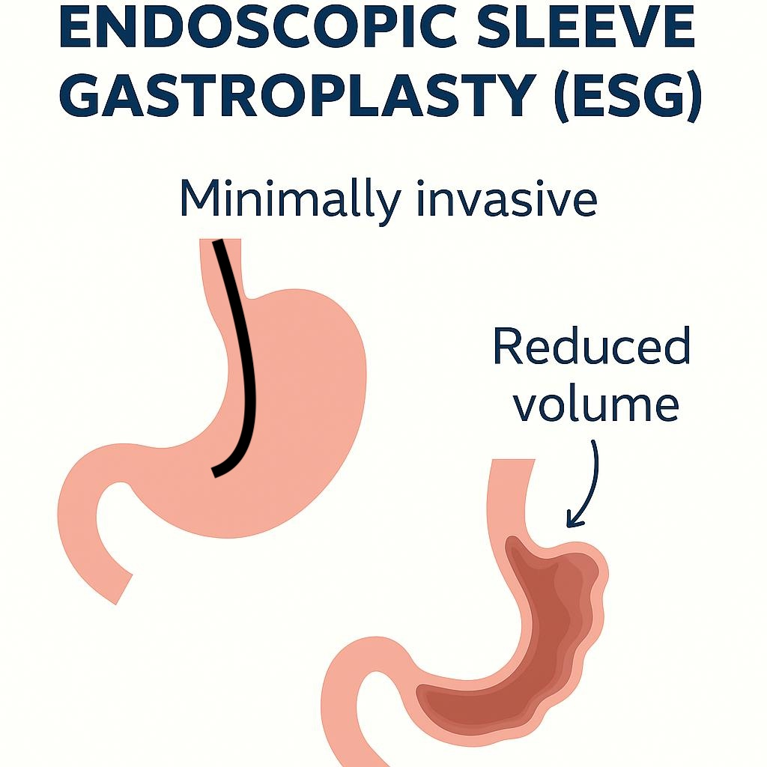
Video resource: To help you see how endoscopic sleeve gastroplasty is done and what to expect, here is a helpful video:
https://www.youtube.com/watch?v=juqqo7PQWEs

2. How Does it Work?
- Restricts how much food the stomach can hold, so you feel full sooner.
- Slows down how quickly food passes through the stomach, prolonging the feeling of fullness.
- May also help reduce hunger via hormonal and mechanical signals.

3. Benefits
- Less invasive than surgical options.
- Shorter recovery time and lower risk of surgical complications like leaks or infections.
- Effective weight loss, though generally less than that of surgical sleeve gastrectomy.
- Improvement in obesity-related conditions (e.g. type 2 diabetes, high blood pressure, fatty liver).

4. The Procedure
- Performed under general anesthetic (you are asleep)
- An endoscope (flexible tube) is passed down your throat into your stomach.
- Using sutures, the stomach is folded and stitched to reduce its internal volume, creating a sleeve shape.
- The procedure takes about 60–90 minutes.
- Usually done with an overnight stay.

5. Risks and Possible Complications
All medical procedures carry risks. With ESG, possible risks include:
- Discomfort, nausea, or pain after the procedure.
- Risk of bleeding or infection.
- Risk of suture breakdown; stitches may loosen over time.
- Less long-term data compared with surgical options; weight regain possible.
- Nutritional issues if diet not followed carefully.

6. Recovery After Procedure
- Usually back to light activities within 1-2 weeks.
- Full return to normal daily activities in about 2- 4 weeks, depending on how you feel.
- Dietary progression needed (liquid → soft → solid) over a number of weeks.
- Follow-up visits with the team (doctor, dietitian) to monitor your progress and address any concerns.

7. Diet After ESG
Stages similar to surgical sleeve:
Stage 1 – Liquids (Weeks 1–2):
- Clear fluids, smooth soups, protein shakes.
- Aim for frequent small sips, 1.5–2 litres per day.
Stage 2 – Pureed foods (Weeks 3–4):
- Blended meals with a smooth consistency (mashed potato, pureed chicken/fish, yoghurt).
- Eat very slowly, tiny spoonfuls.
Stage 3 – Soft foods (Weeks 5–6):
- Soft, moist foods that require minimal chewing (scrambled eggs, minced meat, soft fruit).
Stage 4 – Normal healthy diet (After 6 weeks):
- Gradual introduction of a wide range of solid foods.
- Focus on protein first (meat, fish, beans, dairy), followed by vegetables and small amounts of wholegrains.
Golden rules:
- Eat small, slow meals (stop as soon as you feel full).
- Avoid high-sugar, high-fat foods.
- Avoid fizzy drinks and drinking with meals.
- Lifelong vitamin and mineral supplements are required.
- Stay well hydrated (sip water regularly).

8. Lifestyle Changes
- Adopting healthy eating habits for life.
- Regular physical activity (walking, exercise, strength work).
- Behavioural support or counselling if needed.
- Regular follow-up care.

9. Long-Term Results
- Weight loss tends to be less than surgical sleeve, but quite significant and can improve many obesity-related conditions.
- Success depends heavily on how well diet, activity, and follow-ups are adhered to.

